Working on CS cluster

Prerequisites:
Make sure you have on your computer:
putty (download from here http://www.putty.org/)
ultra-vnc (download from here https://sourceforge.net/projects/ultravnc/)

Connect to one of CS department workstations (math##-lx):
- Launch Putty (a windows SSH client (standard port : 22))
- Choose host (workstation): math05-lx (or 13,14,15)
- Press “Open”

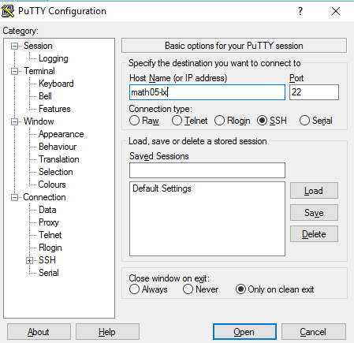

- A terminal window would be opened

- In the terminal window enter your username and password
Congratulations #1, you are now connected to the workstation (not the cluster yet!). What we would like to do now is open a nicer interface to work with. That’s where vnc comes to rescue.
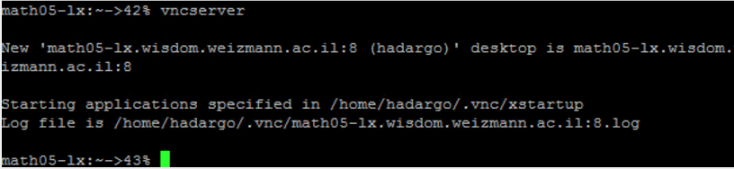
- Inside the terminal, write this command “vncserver”
A vncserver is now launched on the workstation on the given port number (in this picture, the port is 8, you’ll need this number later). That means that we can connect to it with the vnc application (ultra-vnc) and have a nice GUI. Let’s do that:
Connect to the workstations with vnc:
- Open ultra-vnc viewer
- Enter the workstation and port in the “VNC Server” slot and press “Connect”
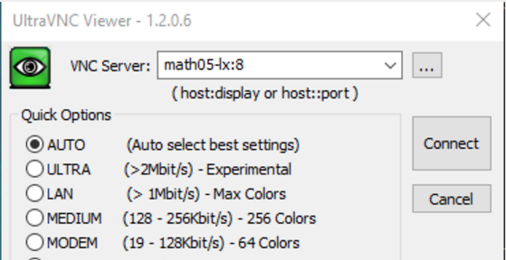

If everything works fine, you’ll be asked for your password again. Now a window with a desktop should open where you can work. You can close this window and connect to it again (doing 7-8 again).
When you don’t need your vncserver anymore, you can close it (from the putty terminal) using the command “vncserver –kill :N” (where N is your port number).
A useful command is vncconfig which lets you configure stuff like sharing the clipboard.
We’re almost done, let’s connect to the cluster.
Connect to the cluster:
- Inside your vnc-viewer desktop, open a terminal (normally you can press right-click and choose “open terminal”).
- Inside the terminal enter the following command
ssh –X mcluster03 qlogin –q all2.q
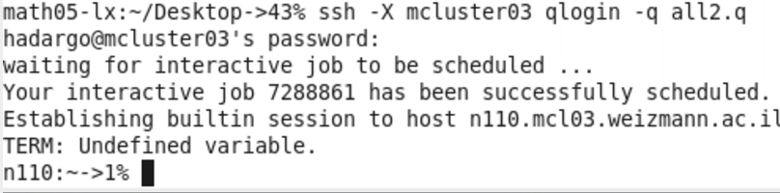
This command is connecting to cluster “mcluster03” with ssh protocol, to the node “all2.q” (there are other clusters and nodes which we would not use at the moment).
You can use “qsh” instead of “qlogin”, that would open a new shell window.
Congratulations, you are now connected to the cluster. Let’s do final setup before we launch our lovely python apps. We would need to define some environment variables.
Inside the cluster terminal, you should run these commands (Change workstation and port to the relevant ones, in our example it’s math05-lx:8):

setenv LD_LIBRARY_PATH /usr/local/cuda/lib64:/usr/local/lib:/usr/local/lib64:/usr/local/cudnn-v5/lib64
setenv PYTHONPATH “/usr/wisdom/python3_ext:/usr/wisdom/python3"
setenv PATH /usr/wisdom/python3/bin:$PATH
setenv CUDA_HOME /usr/local/cuda/lib64
setenv DISPLAY <workstation>:<port>
unsetenv http_proxy

** - We changes the marked line at March 6, 2017 – make sure to use this line instead of the old one.

Or you can run the shell script we provided you on the slack, which does the same. You’ll have to run it each time you connect to the cluster because it “tells” it important things such as where is the python directory on the cluster, and when you open apps with gui, where it should send the display to.

You can now run whatever apps you like, like jupyter or pycharm etc.

