PlayEngine 4.6.0 Installation

Summary:

Version 4.6.0 of the Play-Engine is a standalone version that doesn’t require any previous installation. This version reflects many changes and bug fixes that we have incorporated into the software.

The following list describes the main changes:

- Properties panel was added on the right-hand side of the working area. It contains the property window for elements in the LSC while they are created or edited in play-in mode, and avoids multiple floating windows during play-in. Additionally the Properties panel contains the following 2 sections:

User Hint Panel - displays directions for playing in when applicable.

GUI Application Panel - contains the GUI application window while in play in mode. The GUI application window can be either docked in the panel or float on top of the Play-Engine application.
- File management was changed. User is working with a single entity which is the workspace (user is no longer exposed to other entities, e.g. specification, separately).
- 'New Value' window was changed.
- The process of creating and updating Condition/Assertion was enhanced.
- The process of creating and updating Assignment was enhanced.
- Synchronizing an object in condition, assertion and assignment windows can be done in the old way (right click an object->synchronized) or by using a new control which enables selection of the synched object from a combo.
- Popup menus that appear on GUI objects were added to lifelines on the chart (e.g. store time, time constraint, set property, etc.).
- It is now possible to select objects on the LSC by marquee selection (dashed rectangle).
- Copy\Paste\Cut ability was added. Copy, Paste, and Cut is possible for elements on the LSC (Lifelines, messages, variables and sub charts).

- Undo\Redo ability was added. Undo & Redo is possible for creation and deletion of elements on the LSC. The undo\redo stack saves up to 5 operations. Redo is available only after Undo.
- The following additions were made to save mechanism:
  - Standard save with Ctrl + S

  - Upon exiting user is prompted to save changes.
  - Workspace is Auto Save to a temporary file every X minutes (where X is a parameter in the PlayEngine options). This temporary file is removed when save is explicit. When loading a workspace if a temporary auto-saved file exists, user is prompted with a question whether to retrieve the file, and revert to his unsaved version, useful if the system crashes.
- The option of playing out using random seed was added. The use of random seed introduces randomness to all the points in which the play-out mechanism can progress in different routes. When playing-out with no random seed for a given configuration, the execution always follows the same route. However when a seed is used, different seeds impose different executions.
- User Guide was updated to reflect the new changes.
- License is no longer required

Installation Instructions:

For users who have a previous Play-Engine version installed on their computer

- Back up the default “samples” folder that is located in your Play-Engine installation folder.
- Uninstall any previous Play-Engine version installed on your computer.
- Continue with the instructions as users who install Play-Engine for the first time.

For users who install Play-Engine for the first time

- Unzip the “Play-Engine 4.6.0 Full Version.” zip file.

- Run the "Play-Engine.msi" file.

- In the following window click “Next”.
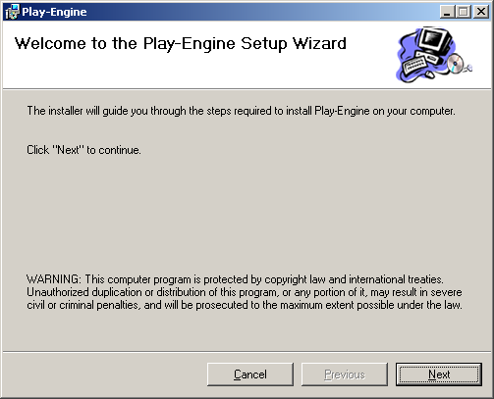

- In the following window choose the required installation folder.
The default folder is “C:\Program Files\Play-Engine”.

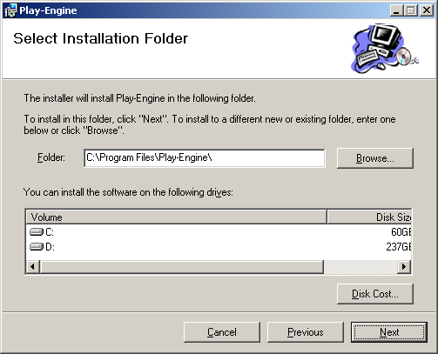

- In the following window click “Next”.

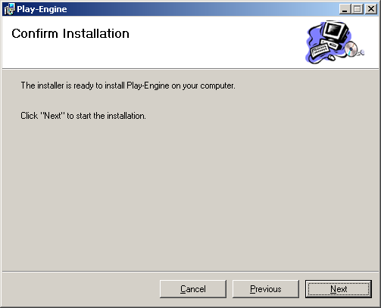

- Wait while Play-Engine installs.

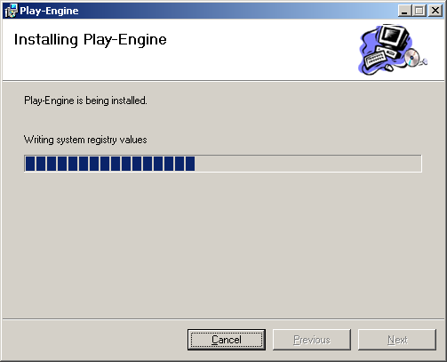

- Click “Close” to finish installation.
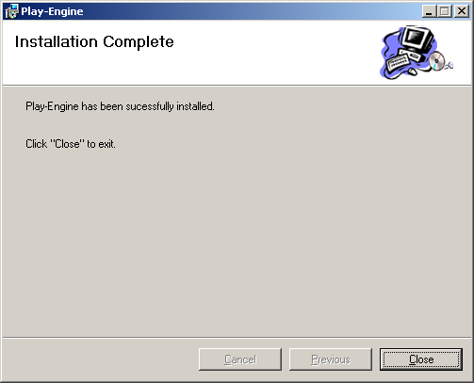

Contact

Please feel free to email us at the address below with any question about the new features or the Play-Engine in general. Use this address also to report bugs you may have encountered; please provide a clear description of the bug, how we may recreate it, the version of the Play-Engine you were working with, and your operating system:
playengine@wisdom.weizmann.ac.il.

